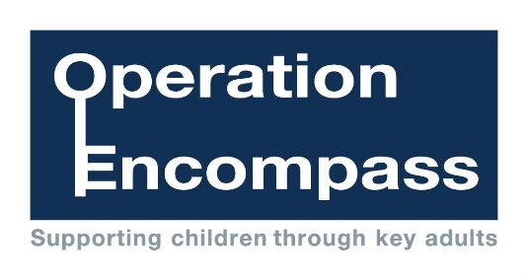

**Encompass Parents Awareness Letter**

Dear Parent/Carer,

Re: Bolton Encompass

Our school is part of a project that runs in partnership with Bolton Safeguarding Children Partnership and Greater Manchester Police.

The project, Bolton Encompass, has been designed to provide early reporting to schools of any domestic abuse incidents that occur outside of school but which might have an impact on a child attending school the following day. This information will be shared on school days during the school term. When incidents occur on a Friday, Saturday or a Sunday, the police will contact the relevant school the following Monday.

A nominated member of school staff, known as a Key Adult, is appointed to liaise with the police. At Gaskell Primary Schoolour Key Adult is Mrs Shelley Bennett (Deputy Head Teacher / Designated Safeguarding Lead). They will be able to use information that has been shared with them, in confidence, to ensure that the school is able to support children and their families. Information will be shared where it is identified that a child or young person was present, witnessed or was involved in a domestic abuse incident.

We always endeavour to offer the best support possible to our pupils and believe that Bolton Encompass is going to be beneficial and supportive for all concerned children and families

Some information about Encompass is included in this letter but if you would like more information about this initiative, details can be viewed online at [www.gaskell.bolton.sch.uk](http://www.gaskell.bolton.sch.uk) or you can contact our Key Adult (Mrs Shelley Bennett) at school *on 01204 333666*.

Thank you for your continued support

Chair of Governors Executive Head Teacher

Ms Sophia Bibi Mr Ian Dryburgh